

**University of Barishal**

**Project Report on**

**“Financial Trends and Growth Analysis of National Life Insurance Company Ltd”**

**Submitted To:**

**Dr. Tania Islam**

Assistant Professor

Department of Computer Science and Engineering, University of Barishal.

**Submitted By:**

Mahamud Hossen

Batch: 65; Roll: 15

EDGE: BU-CSE Digital Skills Training

Computer Fundamentals & Office Application

**Date of Submission:**

**Report Title**

**Financial Trends and Growth Analysis of National Life Insurance Company Ltd.**

# Table of Contents

Table of Contents 3

Chapter 01: Introduction 4

1. Introduction 4

1.1 Rationale of the Study 4

1.2 Objectives of the Study: 4

1.3 Limitations of the Study: 5

Chapter 02: Methodology 6

2. Overview 6

2.1Data Collection 6

2.2 Report Design 6

2.3 Quantitative Analysis Techniques: 6

Chapter 03: Organizational Profile of NLI 7

3. Introduction of NLI 7

3.2 Competitors of NLI 7

3.3 Organogram (Organization Hierarchy) 8

3.4 Corporate Information: 10

Chapter 04: Analysis, Interpretation and Result of the Study 11

4 11

4.1 Gross Premium & Claims Paid 11

4.2 Category of Shareholders 12

4.3 RoA and RoE 12

4.4 Economic Value-Added Statement: 13

4.5 Vertical Analysis 14

Chapter 05: Recommendation and Conclusion 15

5.1 Recommendations 15

5.2 Conclusion 15

Reference 16

# Chapter 01: Introduction

## Introduction

In this internship report, I explore the financial trends and growth patterns of National Life Insurance Company Ltd., one of the prominent players in the insurance sector. This analysis aims to provide a comprehensive view of the company’s financial trajectory over recent years, focusing on key metrics such as revenue growth, profitability, market share expansion, and operational efficiency.

As the insurance industry faces dynamic challenges and opportunities, driven by evolving regulatory landscapes, technological advancements, and changing consumer behaviors, it becomes imperative to examine how well-established companies like National Life Insurance Company Ltd. Adapt and thrive. This report will delve into various financial and strategic analyses to understand the company’s performance and strategic positioning in the competitive market landscape.

This report presents a comprehensive analysis of the financial trends and growth strategies of National Life Insurance Company Ltd. Over an eight-year period, from 2015 to 2022. As a leading player in the life insurance sector, understanding the financial dynamics and strategic positioning of such companies is crucial for stakeholders, including investors, policymakers, and industry analysts. National Life Insurance Company Ltd.

1.1 Rationale of the Study

The rationale for undertaking this study stems from the significant role that National Life Insurance Company Ltd. Plays in the insurance sector and its substantial impact on various stakeholders ranging from policyholders to investors

* **Understanding Economic Impact:** Analyzing the financial trends of National Life Insurance Company Ltd. Helps in understanding how the company contributes to and navigates the economic conditions it operates within.
* **Assessing Financial Health:** By examining key financial metrics such as profitability, liquidity, and solvency ratios, this study aims to provide a clear picture of the company’s financial stability and operational efficiency.

## 1.2 Objectives of the Study:

The primary objectives of this study are structured to provide a detailed understanding of the financial health, strategic direction, and competitive landscape of National Life Insurance Company Ltd.:

* **To Analyze Financial Performance:** Assess the revenue growth and profitability of National Life Insurance Company Ltd. Over the past five years. Evaluate the efficiency of expense management and its impact on the company’s bottom line.
* **To Understand Strategic Initiatives:** Examine the effectiveness of the company’s product diversification and market expansion strategies. Review technological advancements implemented by the company and their impact on operational efficiency and customer service.

## 1.3 Limitations of the Study:

The scope and accuracy of this study are subject to several limitations that stem from practical constraints and the nature of the data available. These limitations are important to acknowledge as they impact the conclusions and the overall comprehensiveness of the analysis:

* **Time Limitation:** The duration of the internship was only three months, which significantly limited the depth of analysis that could be conducted.
* **External Economic Factors:** The study’s timeframe includes periods of significant economic fluctuations, such as those induced by the COVID-19 pandemic.
* **Time Constraints:** The study covers data from 2015 to 2022, which, while providing a substantial historical view, does not encompass potential future trends or the impact of very recent developments beyond the study period.

Chapter 02: Methodology **of the Study**

## 2. Overview

This study analyzes the financial trends and growth of National Life Insurance Company Ltd. from 2015 to 2022. The analysis focuses on essential financial metrics including total life fund, gross premiums, claims paid, management expenditures, total assets, paid-up capital, shareholder categories, returns on assets (ROA) and equity (ROE), market value per share, and EPS/dividend rates.

## 2.1Data Collection

**Primary Data:** During my internship, I had the opportunity to gather firsthand data through discussions with senior employees of NLI

**Secondary Data:** Comprehensive financial data was extracted from the company’s annual reports from 2015 to 2022. This included key financial metrics such as total life fund, gross premiums, claims paid, management expenditure, total assets.

## 2.2 Report Design

The report is designed to offer a sequential analysis of several critical financial aspects:

**Life Fund Analysis:** Evaluates the growth of the total life fund from 2015 to 2022 to assess the company's capacity to underwrite policies.

**Premiums and Claims:** Analyzes trends in gross premiums and claims paid, providing insight into the company's underwriting effectiveness and claim settlement practices.

# **2.3 Quantitative Analysis Techniques**:

**Growth Rate Calculation:** {Growth Rate} = {(Current Year Value - {Previous Year Value) ÷Previous Year Value} ×100

**Financial Ratios:** Various ratios such as ROA = (Net Income ÷ Total Assets) ×100, ROE = {(Net Income) ÷Shareholder's Equity} ×100.

**Graphical Representation:** Uses charts and graphs to visually depict trends and changes in key financial metrics.

# Chapter 03: Organizational Profile of NLI

## 3. Introduction of NLI

National Life Insurance Company Ltd. is a leading life insurance provider in Bangladesh, established in 1985 with the goal of offering financial security and peace of mind to its customers. Operating under the stringent regulatory environment of the Insurance Act of 1938, as amended in 2010, the company has consistently upheld its mission to enhance the lives of individuals, families, and communities through a robust offering of insurance products. With a strong commitment to integrity, customer service, and community involvement, National Life Insurance Company Ltd. Remains a pillar in the

## 3.2 Competitors of NLI

Here Top 10 Companies name are noted:

|  |  |  |
| --- | --- | --- |
| **SL No.** | **Company Name** | **Established Time** |
| 01 | Met Life Insurance Company Ltd. | 1952 |
| 02 | Delta Life Insurance Co ltd | 1986 |
| 03 | Popular Life Insurance Company Ltd | 2000 |
| 04 | Pragati Life Insurance Ltd | 2000 |
| 05 | Meghna Life Insurance Company Ltd | 1996 |
| 06 | Life Insurance Corporation (LIC) of Bangladesh Ltd. | 1956 |
| 07 | Sonali Life Insurance Company Ltd | 2013 |
| 08 | Sunlife Insurance Company Ltd | 2000 |
| 09 | Sandhani Life Insurance Company Ltd | 1990 |
| 10 | Mercantile Islami Life Insurance Limited | 2010 |

## 3.3 **Organogram (Organization Hierarchy)**

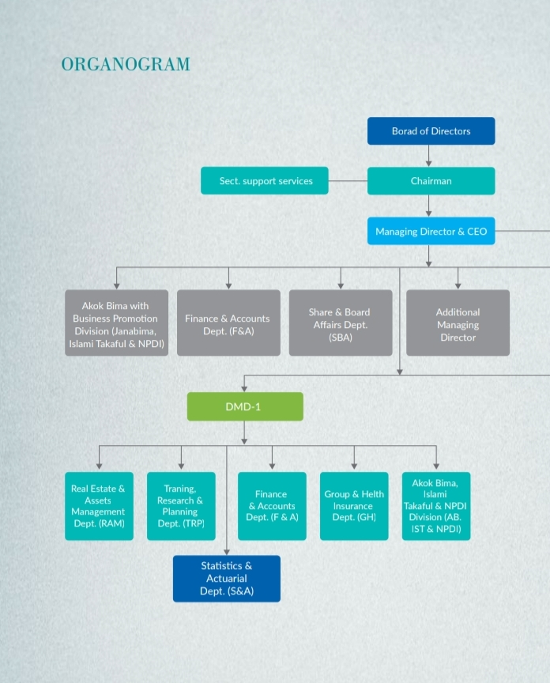

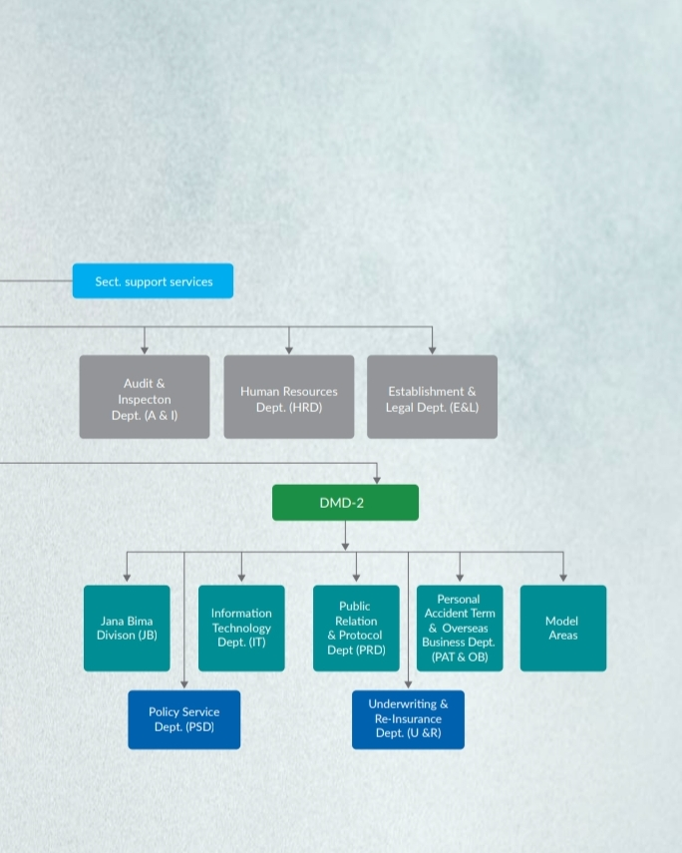

## 3.4 Corporate Information:

|  |  |
| --- | --- |
| **Title** | **Details** |
| Entity Name | National Life Insurance Company Limited. |
| Business Address | NLI Tower, 54-55 Kazi Nazrul Islam Avenue,  Karwan Bazar, Dhaka-1215. |
| Contact | Phone: 09666706050, 41010123-8,  Call Centre-16749 Fax: 88-02-8144237 |
| Current Website | www.nlibd.com |
| Email | info@nlibd.com |
| Registration Number | C-13734 |
| Trade License | TRAD/DNCC/035795/2022 |
| TIN | 460810150961 |
| Commencing Date | 23rd April 1985 |
| Number of Branches | 658 |
| Sponsor Director | Venture Investment Partners Bangladesh Ltd.  National Housing and Investment Ltd. and  Industrial and Infrastructure Development Finance Co. Ltd. |
| Subsidiary | NLI Securities Ltd. |
| Auditors | M/S Mahfel Huq & Co. Chartered Accountants |

# Chapter 04: Analysis, Interpretation and Result of the Study

4. Life Fund Trends and Growth

4.1 Gross Premium & Claims Paid**:**

**Trend Overview:**

From 2015 to 2022, both gross premiums and claims paid by NLI showed an overall increasing trend. Gross premiums increased from BDT 7,815.89 million in 2015 to BDT 16,158.63 million in 2022, while claims paid escalated from BDT 6,518.19 million to BDT 10,520.75 million over the same period.

force efficiency or a strategic shift towards more cost-effective sales practices.

## 4.2 Category of Shareholders

The analysis of the category of shareholders for National Life Insurance Company Ltd. As of December 31, 2022, sheds light on the company’s ownership structure and potential influence on its governance and strategic direction.

## 4.3 RoA and RoE

4.4 Economic Value-Added Statement: **BDT in Million**

|  |  |  |  |  |  |
| --- | --- | --- | --- | --- | --- |
| Particulars | 2018 | 2019 | 2020 | 2021 | 2022 |
| Market value of total Equity | 23,462.45 | 27,228.17 | 27,618.84 | 23,939.95 | 19,425.43 |
| Less Book value of Equity | 1085.22 | 1085.22 | 1085.22 | 1085.22 | 1085.22 |
| Market Value Added | 22,377.23 | 26,142.95 | 26,533.62 | 22,854.73 | 18,340.21 |
| Total Number of Shares Outstanding | 108,521,981 | 108,521,981 | 108,521,981 | 108,521,981 | 108,521,981 |
| Market value per Share (in BDT) at year end | **216.20** | **250.90** | **254.50** | **222.60** | **179.00** |
| Book value per share | 10.00 | 10.00 | 10.00 | 10.00 | 10.00 |

**Trend of Market Value Per Share in Graphical Presentation:**

## 4.5 Vertical Analysis

**Balance Sheet (Statement of Financial position)**

|  |  |  |  |  |  |
| --- | --- | --- | --- | --- | --- |
| **Particular** | **2022** | **2021** | **2020** | **2019** | **2018** |
| **Capital and Liabilities** |  |  |  |  |  |
| Share Holder’s Capital |  |  |  |  |  |
| Authorized |  |  |  |  |  |
| 2000000000 Ordinary Share of Tk.10/- each | 0.00% | 0.00% | 0.00% | 0.00% | 0.00% |
| Issued, Subscribe and Paid up |  |  |  |  |  |
| 108,521,981 Ordinary Share of Tk. 10/- each | 1.97% | 2.05% | 2.21% | 2.39% | 2.55% |
| Life Insurance Fund | 87.08% | 82.78% | 81.62% | 81.54% | 81.20% |
| Due to Other Persons or Bodies | 0.30% | 0.28% | 0.23% | 0.19% | 0.16% |
| Fair Value Changes Account | -0.59% | 0.03% | -0.37% | -1.07% | -0.16% |
| Liabilities and provisions | 11.24% | 14.85% | 16.31% | 16.95% | 16.26% |
| **Total Capital and Liabilities** | 100.00% | 100.00% | 100.00% | 100.00% | 100.00% |

# Chapter 05: Recommendation and Conclusion

## 5.1 Recommendations

Based on the comprehensive analysis and findings from your internship report on “Financial Trends and Growth Analysis of National Life Insurance Company Ltd.,” here are some tailored recommendations to guide the company’s future strategic decisions and ensure sustained growth and financial health:

1. **Enhance Liquidity and Solvency Management:**

* **Optimize Asset Allocation:** Continue to improve asset allocation strategies to maintain or enhance liquidity and solvency ratios.
* **Robust Risk Assessment:** Regularly update risk assessment protocols to reflect current market conditions and potential future risks, ensuring the company remains well-prepared for any adverse changes.

1. **Strengthen Market Position Amid Economic Uncertainties:**

* **Market Adaptation Strategies:** Develop and implement strategies that allow rapid adaptation to changing market conditions.
* **Focus on Customer Retention:** Enhance customer service and retention strategies, possibly through personalized insurance products or loyalty programs, to sustain market.

## 5.2 Conclusion

In conclusion, National Life Insurance Company Ltd. stands as a resilient entity in the competitive insurance market of Bangladesh, with solid foundations and promising growth prospects. The insights derived from this internship will not only contribute to academic knowledge but also aid in strategic planning and decision-making within the company. As the insurance market continues to evolve, the company's ongoing adaptation to market conditions and regulatory environments will be crucial for its sustained success and long-term viability.

## Reference

Azam, M., & Khan, S. (2018). Threshold effects in the relationship between inflation and economic growth: Further empirical evidence from the developed and developing world.

Halim, H., Astuty, P., & Hubei, M. (2022). Effect of inflation and consumption credit on purchase power of the community.

Bagus, P., Gabriel, A., & Howden, D. (2014). Causes and consequences of inflation.

Andiroba, G. A., Okolie, P. I. P., & Oleka, D. C. (2018). Analysis of inflation and its effect on economic growth in Nigeria.

Asaduzzaman, M. (n.d.). Analysis of inflation dynamics. Retrieved from https://mpra.ub.uni-muenchen.de/110333/

Abidemi, O. I., & Maliq, S. A. (2010). Analysis of inflation and its determination in Nigeria.

Ahmed, N., & Mortaza, M. (2005). Inflation and economic growth in Bangladesh: 1981–2005. *Working Paper Series: WP 0604*. Policy Analysis Unit, Research Department, Bangladesh Bank.

Barro, R. J. (1995). Inflation and economic growth. *National Bureau of Economic Research (NBER) Working Paper No. 5326*.

Biswas, B. P., et al. (2016). Determining the growth-maximizing threshold level of inflation in Bangladesh. *Working Paper Series*. Research Department, Bangladesh Bank.

Bruno, M., & Easterly, W. (1998). Inflation crises and long-run growth. *Journal of Monetary Economics*.